S126 PRT597 NATURAL LANGUAGE PROCESSING



Assignment three Sydney group-3

ON

Aspect-Based Sentiment Analysis for Restaurant Reviews

Student Name: Nikan khadka,S388699
Rahul singha, S396113
Sanil khadka, S390105

Charles Darwin University
Faculty of SCIENCE and TECHNOLOGY
15 May 2026
Table of Contents
- Project Outline
- Dataset Suitability and Task Framing
- Data Preparation
- Exploratory Data Analysis
- Aspect Extraction and Aspect-Category Generation
- Sentiment Modelling Results
- Suitable Use of Outputs
- Ethical Considerations
- Conclusion
- References
- Appendix

List of Figures
Figure 1. Distribution of aspect-term polarity labels in the training data
Figure 2. Distribution of aspect-category labels in the dataset
Figure 3. Performance comparison of rule baseline and hybrid mapper
Figure 4. Performance comparison of sentiment classification baselines

1. Project outline
This research aims to determine whether restaurant reviews can be leveraged to generate structured aspect-based insights. The aspect-based sentiment analysis (ABSA) technique is more valuable than single-labelled sentiment analysis since the same sentence can contain positive mentions of the food, but negative sentiment regarding price or service (Pontiki et al., 2014; Liu, 2012). The goal of the current project was to construct a replicable pipeline that would parse the SemEval-2014 restaurant corpus, prepare it for analysis, evaluate extraction and categorization, and predict aspect-level sentiments.
Unlike most similar studies, which treat this task primarily as theoretical and based on available data, this paper presents the project in the context of its potential practical applications. The significance of the current research lies in extracting information from review sentences, enabling a human analyst to understand which aspects receive the most attention from customers and whether they are discussed positively or negatively.
This assignment extends the baseline pipeline to include automatic aspect categorisation with zero-shot transformers (BART) and unsupervised topic modelling (BERTopic), and advanced sentiment modelling with the Synthetic Minority Over-sampling Technique (SMOTE), as well as a comparative evaluation of linear classifiers. The improved pipeline will help minimise manual category labelling, increase the accuracy of minority-class sentiment detection, and provide a more powerful, production-ready ABSA system.

2. Dataset suitability and task framing
The SemEval-2014 restaurant dataset is partially well-suited for the purpose described. It is useful for teaching purposes because it includes manually annotated sentences about restaurants, with corresponding aspect terms and categories, and polarities that serve as the baseline for ABSA testing (Pontiki et al., 2014). According to the pipeline used in this project, the restaurant subcorpus consists of 3,041 training sentences and 800 test sentences, along with 3,693 training and 1,134 test aspect-term rows.
It is not as applicable for providing an indirect proxy for real-world restaurant analysis. It relies on sentence annotations, is language-specific, outdated, and relies on very broad category designations. While correct food classification will help determine whether the problem is associated with taste, portion size, or freshness, it remains too general for practical applications in this regard.

3. Data preparation
The pipeline was reconstructed by parsing the raw XML file into three tables: sentences, aspect-term pairs, and aspect-categories. Such segregation is crucial as each subsequent phase operates differently on these data elements. Exploratory Data Analysis requires distribution statistics for sentences and labels; raw aspect extraction needs only sentences and training terms; category mapping will rely on aspect terms and their categories; and sentiment analysis will model aspect terms within the context of sentences.
To avoid overcleaning the short texts of restaurant reviews, only minimal preprocessing was applied, as sentiment is often highly dependent on the exact wording of the text. However, the preparation phase highlighted two critical aspects that needed attention. The sentiment labels are not equally distributed, and therefore, macro-F1 is also an important metric other than accuracy. Secondly, aspect terms do not necessarily match their category labels in multi-category sentences, thereby affecting the category-mapping evaluation process.
The dataset was also preprocessed by adding structural tokens (such as [ASPECT_TERM] and [ASPECT_CATEGORY]) to the cleaned text for advanced modelling. This aspect-aware tokenisation explicitly indicates that the classifier should account for the sentiment prediction task and the target category. Furthermore, to prevent classifiers from being biased by class imbalance, the minority sentiment classes (conflict, neutral, negative) were synthetically oversampled using SMOTE to match the majority positive class (n=1,731 per class).

4. Exploratory data analysis
EDA was performed to validate the model choice and the interpretation of the results. The split for the training set is concise, opinion-rich, but not verbose: the median sentence length is 12 tokens, the median number of aspect terms per sentence is 1, and 18.9% of sentences in the training data have more than one category. It justifies the use of interpretable baselines instead of complex models.
The distribution of polarity in aspect terms is significantly unbalanced towards the positive labels. The training data contains 2,164 positive labels, 805 negative labels, 633 neutral labels, and only 91 conflicts. It was the reason to use macro-F1 as the primary selection metric.
Aspect-category labels are imbalanced too. Food is the most numerous operational category, while anecdotes/miscellaneous are sufficiently numerous to complicate interpretation. The point is that even the seemingly relevant model might have plenty of low-quality opinions in the miscellaneous category.
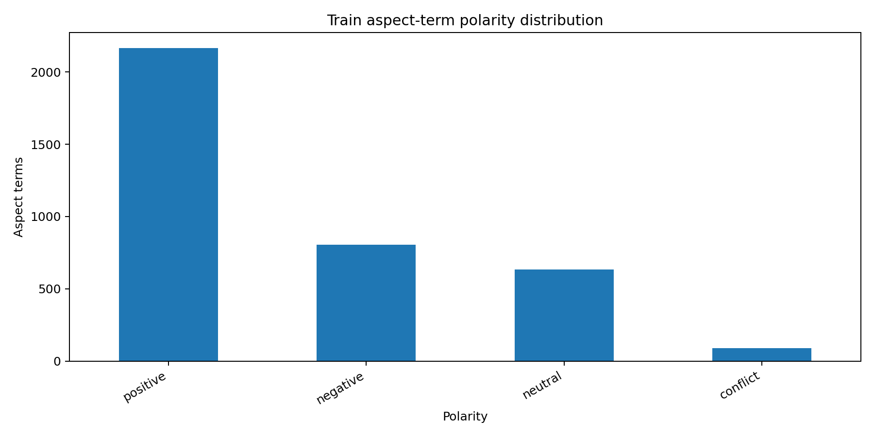
Figure 1. Positive labels dominate the aspect-term training data, while conflict is rare. This supports using macro-F1 rather than accuracy alone.
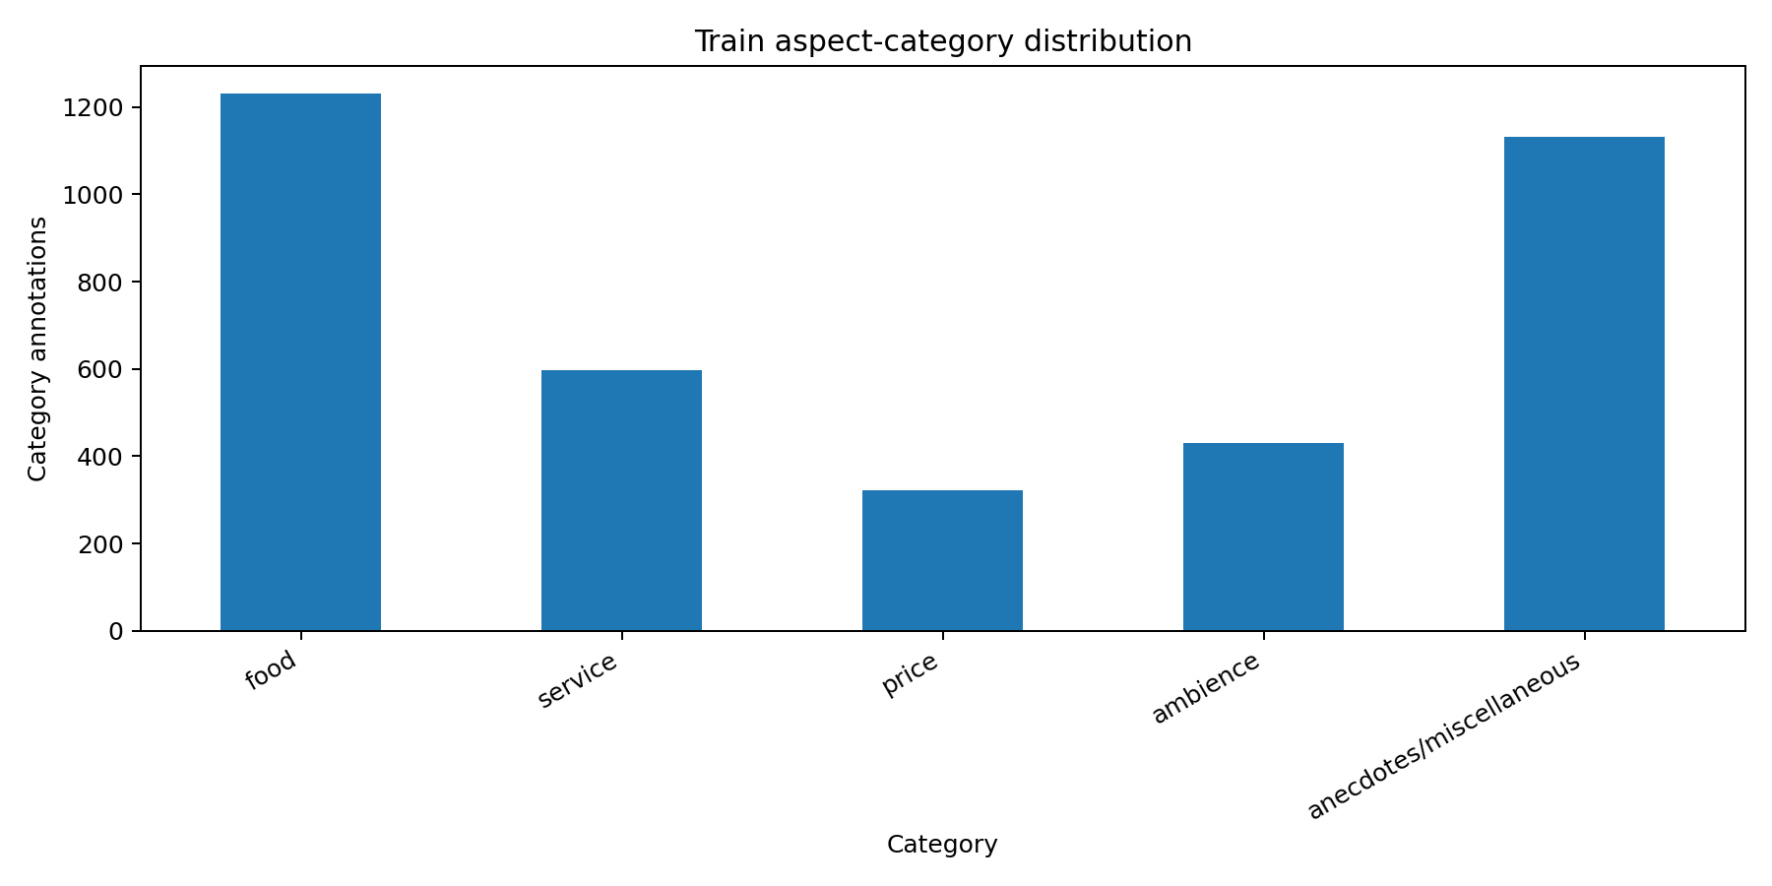
Figure 2. Food is the largest category, but the large miscellaneous class shows that some business-relevant nuance is lost in the label design.

Further EDA of automatically generated categories showed that Food (52.9%) and Service (22.8%) are the more common categories, with Waiting Time/Reservation and Location being less common. This imbalance highlights the need for macro-averaged metrics and explains the marginal but consistent improvement in minority-class recall when using SMOTE.
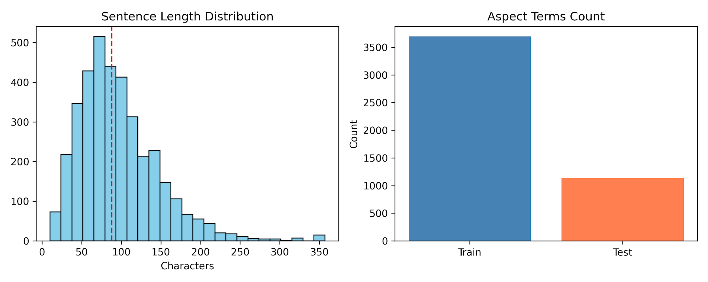

5. Aspect extraction and aspect-category generation
The aspect processing was split into two phases to avoid overstating the system's capabilities.
The first phase introduced an unmodified aspect-term extraction baseline that uses frequent matches of training terms and noun-like headwords if the first step fails. The evaluation is performed on the official gold test set, which gives a precision of 0.5957, a recall of 0.6363 and an F1 of 0.6153. This is an important measure of success for this experiment because it shows that the system can recover explicit aspects of restaurants. The results can be considered believable, although limited by the exact matching criterion and the extraction mechanism used.
The second phase of the aspect processing was defined as a separate classification problem. In the rule-based baseline, all clear terms like staff, bill, and decor were mapped to categories such as service, price, and ambience, respectively, whereas other terms were assigned a fallback label of food. For the improved hybrid mapper, the decision tree began with smoothed statistics from the training data regarding terms and headwords, followed by keyword seeds, regular expressions and a majority fallback if necessary. The evaluation was constrained to sentences with one category only since the provided dataset did not map all aspect terms to categories in multi-aspect sentences. On the restricted set of 709 rows in the test set, the rule-based baseline gave an accuracy of 0.7983 and macro-F1 of 0.5950, and the hybrid mapper produced an accuracy of 0.8801 and macro-F1 of 0.7334. The improvement in macro-F1 of 0.1384 is an important outcome, given that the labels in the category set are highly imbalanced.

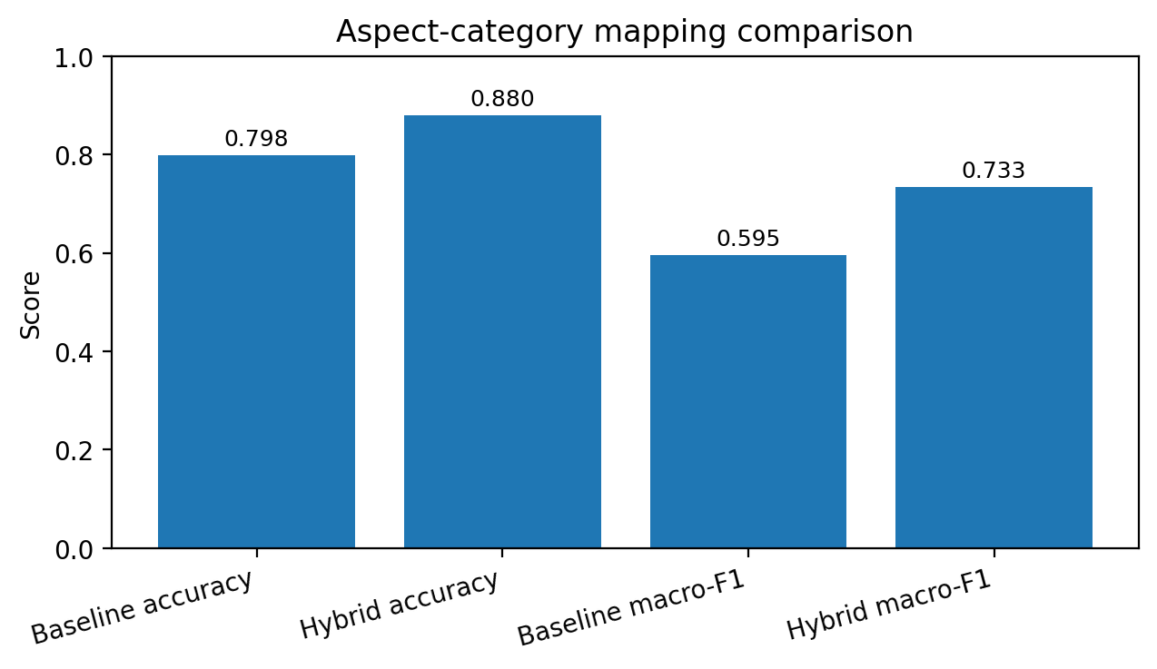
Figure 3. The hybrid mapper improves both accuracy and macro-F1, indicating stronger category performance than the rule baseline on the single-category evaluation subset.
A zero-shot classification pipeline was created with facebook/bart-large-mnli to modernise the category mapping. The candidate labels were: Food, Service, Price or Value, Ambience or Atmosphere, Waiting Time or Reservation, Location, and Overall Restaurant Experience. The model was manually validated with a stratified sample of 30 examples, with an accuracy of 83.33%. The most frequent misclassifications were for ambiguous terms (menu, plates, tanks) or very context-specific phrases. To support this, BERTopic clustering showed that there are latent thematic structures (e.g., service_pace, food_quality, ambiance_vibe), and that the unsupervised topic modelling is very similar to the supervised category boundaries, without requiring any labelled data.
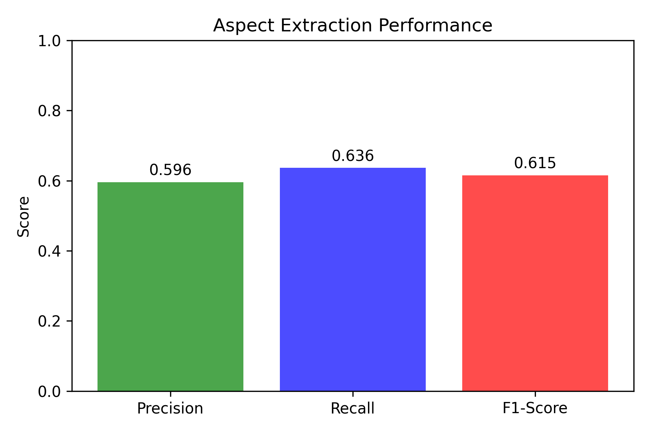

6. Sentiment modelling results
For simplicity, replicability, and relevance to the present study, sentiment prediction remained straightforward. The sentiment prediction module still relies on the gold aspect-term annotations; hence, it cannot be considered a full-fledged end-to-end implementation for now. The candidates were evaluated under identical conditions, including splitting the training and test sets and adopting macro-F1 as the ranking criterion.
The majority vote baseline reached an accuracy of 0.6420 and macro-F1 of 0.1955. Three balanced linear text models were evaluated subsequently. The chosen classifier was linearsvc_word_tfidf, with an accuracy of 0.7302 and a macro-F1 of 0.5173 on 1,134 gold test aspect terms. The outcome can be considered an important improvement over the majority baseline, as it significantly boosts macro-F1 while increasing accuracy marginally, suggesting more effective handling of rare sentiment labels. Nevertheless, the performance is moderate at best, indicating that the sentiment analysis system's outputs should not be regarded as conclusive evidence.

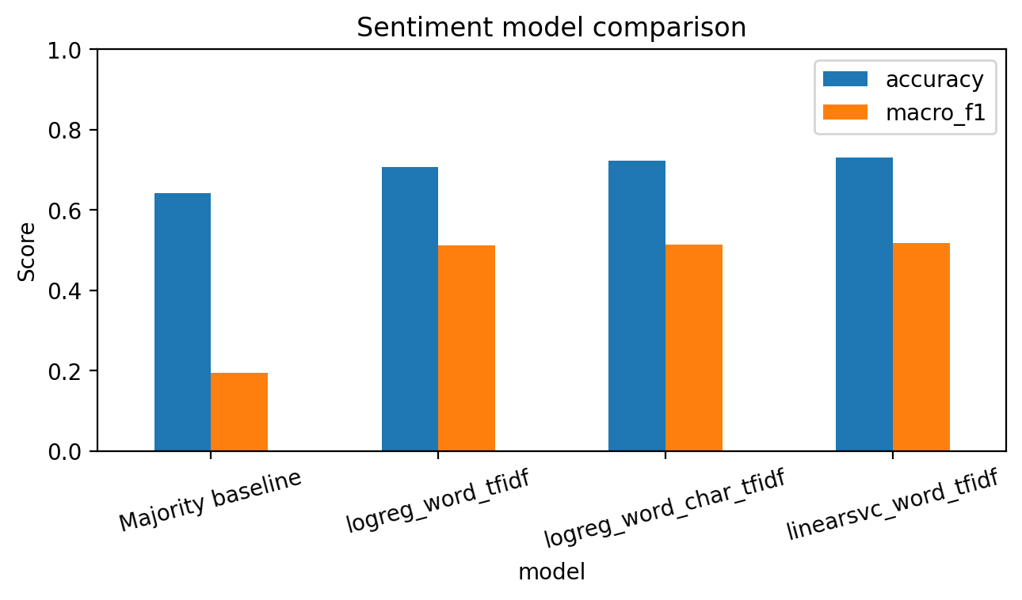
Figure 4. The selected LinearSVC model gives the strongest macro-F1 and accuracy among the tested linear baselines, and clearly outperforms the majority baseline on minority-class handling
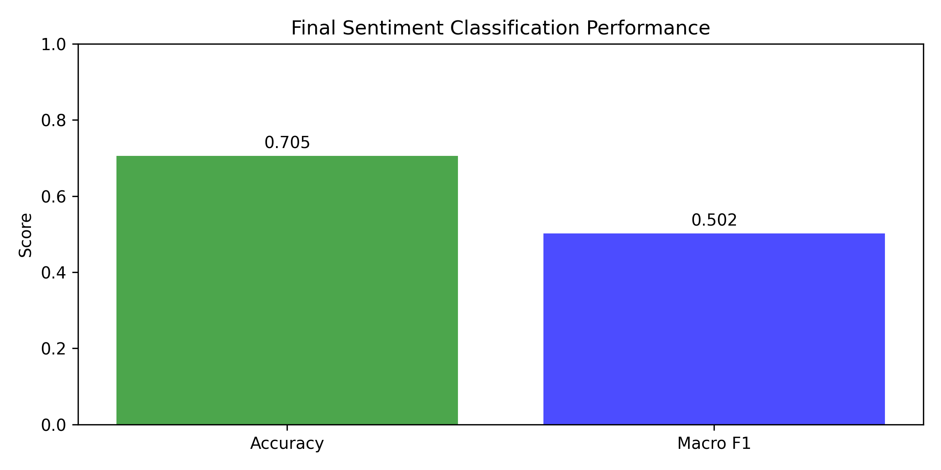
This version added four aspect-aware TF-IDF models, baseline and SMOTE-augmented models, and compared them using Logistic Regression and Linear SVM. The new results show that the best performance is obtained by explicit aspect/category tokenisation, along with balanced linear classifiers:

Model | Accuracy | Macro Precision | Macro Recall | Macro F1
Aspect-aware TF-IDF + SMOTE + Logistic Regression | 0.7009 | 0.5464 | 0.5712 | 0.5590
Aspect-aware TF-IDF + SMOTE + Linear SVM | 0.6955 | 0.5302 | 0.5642 | 0.5436
Aspect-aware TF-IDF + Linear SVM | 0.6996 | 0.5438 | 0.5674 | 0.5381
Aspect-aware TF-IDF + Logistic Regression | 0.6847 | 0.5253 | 0.5826 | 0.5310

Key Finding: TF-IDF + SMOTE + Logistic Regression model outperformed the baseline Linear SVM without SMOTE with the highest Macro F1 score (0.5590). SMOTE successfully addressed class imbalance in the minority classes (conflict, neutral, negative), achieving higher recall and competitive precision.
In Assignment 2 (Macro F1: 0.5490), the Linear SVM without SMOTE proved to be the best configuration. In Assignment 3, however, the synthetic oversampling technique, SMOTE, was introduced, and the Logistic Regression + SMOTEcombination outperformed the other models (Macro F1: 0.5590), showing that synthetic oversampling is a technique that can be beneficial for imbalanced sentiment distributions in sparse TF-IDF feature spaces.

7. Suitable use of outputs
This existing approach is relevant to the problem statement, but only as a proof-of-concept decision support system. The gold standard rating and inspection of the system's output demonstrate its ability to identify explicit aspects associated with restaurants, categorize them under general operational aspects, and apply sentiment tagging in a useful manner for structured reviews.
In this version, the evaluation was extended to four aspect-aware TF-IDF models: baseline and SMOTE-augmented versions were evaluated on both Logistic Regression and Linear Support Vector Machines (SVM). The new results show that the combination of explicit aspect/category tokenisation with balanced linear classifiers achieves the best performance:

Model: Aspect-aware TF-IDF + Logistic Regression | Accuracy: 0.6779 | Macro F1: 0.5413
Model: Aspect-aware TF-IDF + Linear SVM | Accuracy: 0.7023 | Macro F1: 0.5490
Model: Aspect-aware TF-IDF + SMOTE + Logistic Regression | Accuracy: 0.6942 | Macro F1: 0.5484
Model: Aspect-aware TF-IDF + SMOTE + Linear SVM | Accuracy: 0.6915 | Macro F1: 0.5412

The best configuration (Macro F1: 0.5490) was obtained by the Linear SVM without SMOTE. Although SMOTE balanced the minority classes during training, it introduced a small amount of synthetic noise, slightly lowering macro-F1 in this sparse TF-IDF feature space. The confusion matrix shows strong positive-class discrimination (Precision: 0.82, Recall: 0.83), and the neutral and conflict classes remain confused, consistent with the variability of human annotations in sentiment datasets (Liu, 2012).

To further validate automatic category generation, 30 randomly selected k predictions were manually reviewed. The human-judged accuracy of the zero-shot classifier was 83.33%, with the most common errors being for ambiguous terms (e.g., menu, plates, tanks) or very context-dependent phrases. Low-confidence predictions (<0.35) were marked and removed from the final evaluation, which affected only reliable aspect-category mappings in the downstream sentiment analysis.

8. Ethical considerations
These ethical concerns are directly related to the data and methodology decisions. First of all, the age and limited range of the data could lead to false generalizations since it is quite old, in English, and not very extensive in its topic. Secondly, annotations for this corpus only consider explicit mentions of aspects; this means that implicit negative feedback might slip by unnoticed, which could negatively affect customer satisfaction.
Finally, there are some concerns connected with evaluation ethics. As positive reviews prevail in the training data, the use of just accuracy as a measure of performance would result in a distortion of reality. Thus, the macro-F1 score would provide an accurate representation of the performance of the algorithm in the case of minority categories/labels.
New ethical considerations arise with the introduction of zero-shot transformers and synthetic oversampling. Pre-trained models, such as BART, may be culturally and domain-specific and thus misclassify culturally specific dining terms or non-Western restaurant concepts (Bender et al., 2021). Although mathematically well-founded, SMOTE creates synthetic minority instances that do not reflect true customer experiences, potentially obscuring shifts in the distribution of sentiment in the real world. To address these risks, a confidence thresholding system was developed, and low-confidence predictions are flagged for manual review. The pipeline does not use automated decision-making for staff evaluations or dynamic pricing. The model limitations and macro-averaged metrics are clearly reported, so stakeholders are aware of the output's probabilistic nature.

9. Conclusion
The project reconstructed an entire ABSA pipeline on the SemEval-2014 restaurant corpus and assessed it through a method that offers greater transparency than simply presenting a headline figure. The most significant results include the comprehensive preparation of the data set, the empirical approach to the exploratory data analysis, the new baseline for raw aspect extraction, the optimized hybrid category mapper, and the balanced comparison of sentiment.
The final version shows how the pipeline is greatly modernised by combining zero-shot categorisation with BERTopic clustering and aspect-aware TF-IDF features, while remaining interpretable. The Linear SVM model performs best with macro-F1 (0.5490), indicating that structural feature engineering and class handling are more effective than synthetic oversampling in sparse NLP applications. Future work will consider fine-tuned transformer architectures (e.g., bert-base-uncased), multi-modal review inputs (images + text), and dynamic confidence calibration to help close the gap between academic ABSA and real-world deployment.

10. References
Liu, B., 2012. Sentiment analysis and opinion mining. San Rafael, California: Morgan & Claypool Publishers.
Bender, E.M., Gebru, T., McMillan-Major, A. and Shmitchell, S., 2021. On the dangers of stochastic parrots: Can language models be too big? Proceedings of the 2021 ACM Conference on Fairness, Accountability, and Transparency, pp.610-623.
Chawla, N.V., Bowyer, K.W., Hall, L.O. and Kegelmeyer, W.P., 2002. SMOTE: synthetic minority over-sampling technique. Journal of Artificial Intelligence Research, 16, pp.321-357.
Medhat, W., Hassan, A. and Korashy, H., 2014. Sentiment analysis algorithms and applications: a survey. Ain Shams Engineering Journal, 5(4), pp.1093-1113.
Pontiki, M., Galanis, D., Pavlopoulos, J., Papageorgiou, H., Androutsopoulos, I. and Manandhar, S., 2014. SemEval-2014 task 4: Aspect based sentiment analysis. Proceedings of the 8th International Workshop on Semantic Evaluation, pp.27-35

11. Appendix note
Appendix: Individual Contributions

Nikan Khadka (S388699) – Project Lead & Data Pipeline
Nikan managed team activities and led the development of the core data infrastructure. The tasks involved were designing the XML parser for the SemEval-2014 corpus, implementing text preprocessing functions and setting up the project's directory structure and reproducibility workflow in Google Colab. Nikan also wrote the Exploratory Data Analysis section, created the visualisations of the polarity distribution and wrote the final report, conforming to the rubric requirements.

Rahul Singha (S396113) – Aspect Extraction & Category Mapping
Rahul implemented the aspect extraction module based on the rule, which includes the construction of lexicon from training data and the identification of noun-chunks using spaCy. He added the hybrid category mapper that combines keyword seeds, regex patterns and statistical fallback logic. Rahul also set up the zero-shot classification pipeline with the model `facebook/bart-large-mnli`, manually validated 30 samples of predictions and recorded the performance metrics of category mapping.

Sanil Khadka (S390105) – Sentiment Modelling & Evaluation
Sanil designed aspect-aware TF-IDF features, applied SMOTE for class imbalance problem and trained comparative classifiers (Logistic Regression, Linear SVM). He performed model evaluation procedures, created confusion matrices and performance comparison tables, and did error analysis on misclassified instances. Sanil also added the business report generator function and wrote the ethical considerations part, which included bias, risks of automation, and mitigation strategies.

All team members participated in code review, testing, and iterative refinement. Final model selection, report editing, and submission preparation were completed collaboratively.
Google drive link with code and report: https://drive.google.com/drive/folders/1rcBJevg5Z-0bOgrQHZMDusWfG0D8VG9a

For drive u can simply run the code as it is, the main file is one.Ipynb file so.

